Joaquin Sabin, Dylan Robens, Austin Weber, Alex Schroeder, Member, IEEE

# INTRODUCTION

This project overviews the subject of Near Field Communication (NFC) by exploring the basics of how NFC communicates and transfers data. It also focuses on how to design a Near Field Communication antenna. The can communicate with passive NFC tags at a practical distance without any noise or excess data interfering with the communication. It then applies the antenna design work by fabricating a custom printed circuit board so that it can be used in the real world and tested in real world scenarios.

The method of showcasing that the antenna is working and functioning as intended is demonstrated with Nintendo’s amiibo figurines that will be used as the communication device for ensuring that the data transfer is working. amiibo are little figures from Nintendo that contain NFC chips (NTAG215) inside them. These chips store tons of data for multiple different games which makes them perfect candidates to see if the antenna is able to accurately transfer data at a fast rate.

# Design Problems and Objectives

The goal for the PCB design element of this project was to create a custom PCB with an integrated NFC antenna that is capable of longer-than-average-range data transfer and support power modularity with each antenna. The NFC readers will interface with a ATMega2560 microprocessor, common cathode multicolored LED lights, power supply, and power transfer nodes. All these elements, combined with a custom shelf-like housing designed and built using a 3D printer, can come together and create a display shelf that scans NFC based collectable figurines and changes the colors of the LED lights accordingly. This will have required multiple iterations of custom PCBs, custom programming, and many iterations of 3D modeling work.

The NFC based collectable figures being used are Nintendo’s amiibo. The reasoning behind using amiibo is for safety and security reasons. The antennas were not designed to enable the ability to collect private or secure data from other NFC chips, such as credit cards, key fobs, and security devices. The amiibo figurines feature an NTAG215 NFC chip that stores game data unique to each figure. This unique data will be used to determine what figure was being scanned, which will then be compared to a database that will return the correct color of lighting for that specific figure.

# Detailed Design Documentation

The project had started with some general ideas and took some time to finalize what exactly it will be. It was decided that creating a display case with the ability to scan figures while also displaying them in a unique way within the case would be a nice concept. The group agreed on this idea and wanted to figure out how to incorporate electrical engineering concepts into a project like this, and the group hadn’t made any custom PCBs without guidance before, so wanted to learn how. It was decided to go with a box design that can house 3 figures at once and is made up of white plastic with a gray outer shell. The main reasons for going for a two-tone design is that it is more visually appealing, and the gray PLA stops light diffusion easily compared to white PLA. This way light will bleed through where intended, and not bleed where it is not intended.

When a figure is scanned, it’s unique figure data from the NFC tag hidden inside of it will be used to light up an LED which has the same color scheme as the figure. There are many ways you can use NFC technology and data depending on the type of chip you are scanning and the application. The antenna will not be able to be used to scan credit card data and personal safety devices. This design choice was done to ensure the project cannot be used in any malicious ways. Showing corresponding LEDs lighting up was decided to be a simple and useful method of displaying to the user that the NFC data is being read. The easiest way to utilize NFC data communication will be to use a multicolor LED, and light it up according to the ID scanned. Between the 2 types of LED lights, (common cathode and a common anode) it was determined a common cathode would be the best to use as it will be easier to supply different voltages to the RGB LED.

The data from the amiibo will be read through wireless data transfer as long as it is within range of an NFC antenna. Researching how NFC antennas work was the main focus of the design from the first semester. The CLRC663 chip was decided to be the best use for the antenna as it is specifically for reading and processing data being received from an NFC antenna. Incorporating this chip into the custom PCB required a dive into the schematics of the chip to find out how the CLRC663 operates.

**Early Conceptual Stages of the Custom PCB:**

The project originally involved a single board with three built in NFC antennas to read data from the NFC chips that were placed on them. This was done for simplicity of manufacturing down the road, but led to being too risky for the project in its current state if the board resulted in not working.

The project was redone as a separate NFC antenna board, combined with a custom-made motherboard designed from Arduino Mega 2560 schematics. This was done to allow modularity for the final product and allow the ability to switch out multiple revisions of NFC antenna boards as new designs were made. Having this capability allowed easier access to testing designs as they came in and more adaptability down the road.

An RC522 chip was originally featured on the NFC antenna PCB but later changed as the RC522 is no longer available. Later this was switched out to the CLRC663 due to part availability and future compatibility with other components. Due this chip being relatively new, public documentation, code, and forum posts were not widely available and led to project delays that affected the end product.

**Antenna Design Calculations:**

After figuring out the design and goals of the project, the next step was to decide on the layout of the antenna PCB. The first step was the general layout. To achieve this, a few days were spent specifying the parameters of the antenna. It was important to know what needed to be scanned in the first place. To get data transferred from the NFC tag to the NFC antenna it was important to know what frequency the NFC tag from the amiibo figure could operate at. Datasheets showed that the figure has an NTAG215 chip inside of it which is able to transfer data at a frequency of 13.56Mhz.

After some research it could be found that an ST25TB or ST25TV series antenna had the required tuning frequency necessary for communicating at 13.56Mhz. Initially it seemed that either the ST25TV or ST25TB could be used but further research showed that the ST25TV series would not work with the NTAG215 chip found in the amiibo figures. From here it was decided to go with the ST25TB series antenna. This provided a great starting point for beginning the antenna calculations.

**Deciding on the Shape of the Antenna:**

Early design revisions of the NFC antenna board featured multiple versions with different antenna shapes. Research was done to determine the most effective antenna shape for the purpose of the NFC Antenna. It was discovered that a circle design has less data loss, but the square design has more stability. It is for this reason that for the antenna design on the NFC antenna board, a square design with rounded edges was featured as the main antenna. This design incorporates features from both the circular and square design that gives us beneficial traits from both. This design was also chosen due to limitations during board development from the software that was primarily used to design said boards. The simplified geometry allowed for easier calculations of antenna properties during development and led to the development of an accurate Smith Chart to aid in the antenna tuning process down the line.

*NFC Antenna Smith Chart*

**Finding The Ideal Operating Range/Distance:**

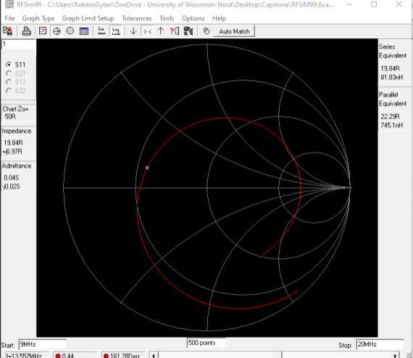

NXP, an RFID/NFC antenna design company, features a simulation tool to find the ideal operating range that would be needed. It also provided useful documentation and made it possible to learn what kind of range the antenna could achieve. The notable details learned here were that a 4cm-diameter antenna would allow for an approximately 3cm operating range to scan the NFC tag.

**Early Antenna Design Equations and Parameter Calculations:**

After the operating range, the shape, and the size of the antenna had been decided, research began to find the necessary equations and information that would be needed in order to calculate the electronic components required for the antenna. Since the EMC filter used for the antenna was static, the matching circuit had to be tuned in the simulation to give the intended result. From here, the next step would be to decide on figuring out the actual antenna-specific values. Research showed that the internal resistance of the coil for the antenna could be found by taking the resistivity of copper, multiplying it by the length of the coil of wire, and dividing it by the cross-sectional area of the overall wire.

After calculating the resistance of the antenna, the inductance of the antenna could be found by using the number of turns, coupling coefficients, resistance of the antenna, and diameter. Once the inductance in the circuit was known it could then be used to find the capacitance. Next, the values were plugged into an online antenna calculator software which was used to double check that all the calculations were accurate and plausible.

**NFC Antenna PCB Design:**

The resulting design and schematic for the NFC antenna PCB was based on the supplier recommended circuit for the CLRC663 and conventional standards for NFC antenna circuits. 0-ohm resistors were utilized throughout the design to reduce EMI and achieve effective data transmission between the CLRC663 and the main processor unit on the custom motherboard. Additional test pins were added in the design to allow for additional debugging capabilities, should issues arise with the board.

*NFC Antenna Custom PCB Design Schematic*

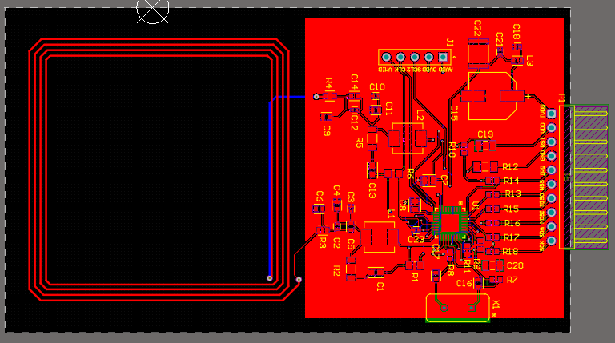

**Custom Motherboard PCB Design:**

In addition to the antenna, a custom motherboard would be needed to have the logic of the system running on it. It was designed and created using an open-source Arduino 2560 schematic as a reference, only including the aspects that would be relevant to this project’s needs. The main things that were changed about this board are the headers that are being used to interface with the NFC readers, LEDs, and various other electronic devices present within the final design. To reduce the cost of the system overall and increase the amount of available space, unused headers were removed when they were not needed for any devices in the system. The main reasons the custom motherboard was created and used in this project was due to the fact that it would allow for a better use of space and provide the additional memory required to store all the amiibo data. Using these custom boards were beneficial because they have the space efficiency of an Arduino Uno with the memory abilities of an Arduino Mega 2560.

**PCB Fabrication**

PCB fabrication was done by JLCPCB, a PCB manufacturing company based in China. It was decided that PCB assembly would be completed during the fabrication process, due to the pick and place capabilities that were featured at their facilities and the complex nature of the custom PCB designs. Due to the location of JLCPCB and miscommunication between the design team and the manufacturer, multiple project delays occurred that affected the end product. When globally sourcing the parts from different manufacturers, multiple shipping delays occurred that pushed the timeline of the project back further and led to less time to debug the boards.

This issue was primarily encountered when ordering the first PCB design, which was the NFC antenna board. After having first ordered the parts that would be required for the board, it took over a month for those parts to be shipped to the JLCPCB manufacturing site. This led to parts that were previously in stock at the manufacturing site being out by the time the previously ordered parts arrived. Due to this, many delays were experienced in receiving the NFC antenna boards and as a result there has been less time to test and debug. This issue was also experienced with the custom Arduino Mega Boards that were created, but to a lesser degree due to previous experience with the capabilities of JLCPCB’s stock options.

**PCB Fabrication Results**

After the custom NFC antenna boards were received, testing immediately began and early testing unfortunately showed that they do not operate as expected. Due to the limited open-source code that is available on the internet for the particular chipset that was used, the boards were not able to function as expected. It was found that its possible to read from the CLRC663 chip on the board. However, the registers from the chip are set with default 1’s and 0’s. In order to program the chip with its intended values, a Clev663BM Programming board would be required to import the program onto our chips. If there was more time to debug these boards and possibly rework the design itself, there could have been a better opportunity to make a immediately functioning board that works as the simulations show they should.

Another large issue was encountered with JLCPCB when the custom motherboard was ordered. JLCPCB incorrectly placed a lot of the IC’s and microchips that were present on the board due to the naming conventions that were used; the manufacturer incorrectly assumed that a lot of the parts had an orientation that did not matter. This led to the board not functioning as expected and being completely unusable with the project. If more time was available, more testing could be done to debug these boards and fix a multitude of the issues that are present.

**3D Modeling**

While the PCBs were being made in Altium, work also began on the necessary housing in which the NFC antennas would rest in. The plan was for the amiibo figures to have a visually appealing shelf-like housing, so they wouldn’t just be resting on a large PCB with a bunch of wires visible to the user.

The original prototype consisted of 11 individual files that would need to be printed to complete one full shelf. The general concept was that the amiibo were to be a slotted into the shelf and rest in place while lighting up LEDs that would correspond to the data being read from the amiibo. The shelf was also made to be easily constructable by hand without the need for any tools. This was to make disassembly faster in case a shelf had an issue. The shelf parts slid on and off easily and constrained the shelf in a physically secure way.

While printing, some of the parts were extremely thin, which led to warping issues for longer prints. This caused many prints to fail in early design stages. Originally the project was utilizing a personal 3D printer to print the needed parts, but this constrained the timeframe of the project as the prints were inconsistent and took quite a while to print. The group was later informed about the printing lab on campus and all 3D printed parts for capstone were supposed to be printed in the lab. The prints had been changed to be made easier by the time the printing restrictions were introduced, so the design had been refined by removing redundant parts and making existing parts more robust to avoid warping. While printing, the group also encountered some issues with removing supports in very tightly cramped places, so the files were changed to remove any instance that would create supports that were troubling to remove.

The second prototype featured a slot for a photo resistor to activate/deactivate an NFC antenna and a slot for the NFC antenna boards to rest under where the amiibo would sit. After designing this prototype, the final design was fabricated at the print lab and the design was constructed. Testing began after the final design was constructed to test out the capabilities of the NFC antennas in conjunction with the Arduino Mega as well as making sure that everything was functioning as expected. During this phase, minor design adjustments were made to increase the efficiency of the system and ensure that it was as “end-user proof” as possible.

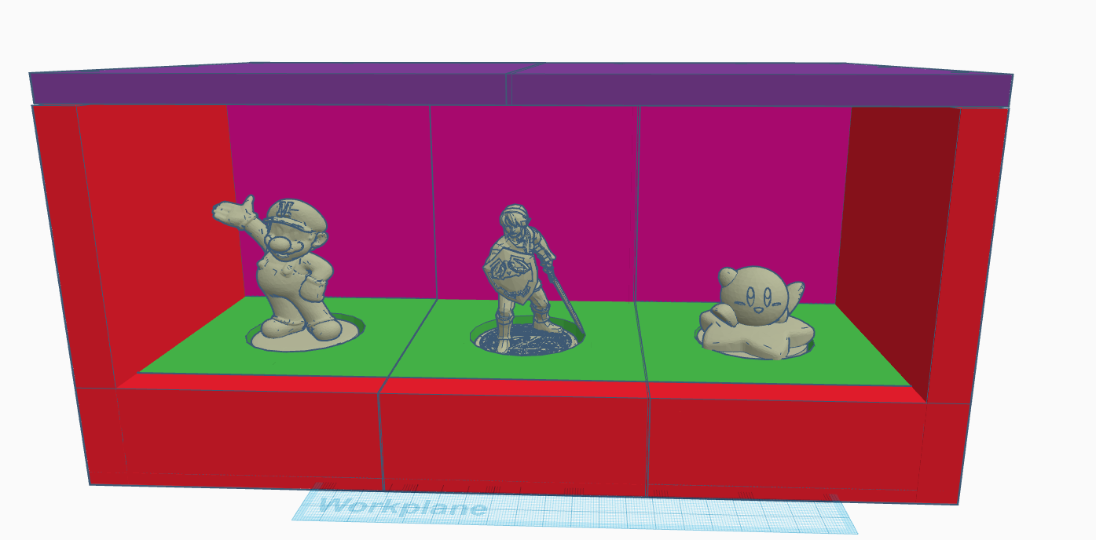

**Arduino Software**

During the planning stages for the software, it was determined that storage space would be an issue due to the large number of figurines the software needed to be compatible with. It was also determined early on that an Arduino-based motherboard would be used for the microcontroller to control this entire project, as this was a device that the team had familiarity with. The storage needs required the use of an Arduino Mega, which contains enough storage space for the head, tail, and color values of each figure.

A goal of the software was to split each sensor into its own class. That way, each sensor could be individually tested to make sure it was functioning properly. The program utilizes three main classes: one for the MFRC522 board, one for the photoresistors, and one for the LED logic. The MFRC522 and LED lights that were purchased both had recommended libraries for interacting with them, which assisted in the programming process. This meant that the focus could be on new aspects of the program, rather than learning how each external device functioned. The photoresistor class was custom made, and although simple, was extremely helpful in making the code clean and concise.

The main loop that runs the device checks each photoresistor to see if one has dropped below a light threshold determined on startup, which means a figure has been placed inside of a slot. If true, the NFC board will read the figure, take the received data, and search for a match within the database. It returns the match and changes the LED lights accordingly. Once a figure has been placed, the program checks if the photoresistor exceeds a preset threshold. If it has, then a figure has been removed from a slot. The program then turns off the respective lights and waits for a new figure to be placed.

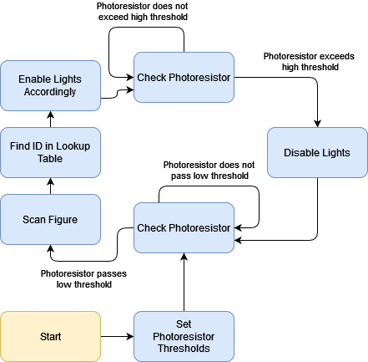

# Safety

When it came to safety in the design, the goal was to provide as few points as possible for an individual to interact with the electronics in the project. A shroud was designed for the electronics that allowed for the antenna to still scan the NFC chip that was placed close to the antenna. That way, the optimum functionality of the device was maintained while reducing the amount of risk that the user would experience. The plan was for the user to never be able to interact with the wiring, and give a sort of “magical” feeling when placing and removing the figurines.

In terms of the antenna design itself, the antenna was designed so that it would only operate at a specific frequency of 13.56 MHz. which would remove the ability for the antenna to scan other chips that weren’t operating at the same frequency and therefore prevent the ability to steal data that the system isn’t designed for.

# ETHICAL CONSIDERATION

Although the system poses no danger or ethical concerns to people, it does interact with a piece of proprietary technology created by a multi-billion-dollar company. It is very important that the project does not infringe on any copyright or trademark by Nintendo and its subsidiaries. This only applies to the code created to interact with the amiibo figures, which are distributed by Nintendo. Much of the amiibo data is not encrypted, including the 2 “pages” (four bytes each) of data used by the program. However, pages 40 to 130 are encrypted by a private data key owned by Nintendo and is not released to the public. Using this key would directly be a violation of Nintendo’s copyright and could cause legal trouble. Thus, the project does not violate ethical codes as it does not use this data key.

The project also makes use of multiple open-source libraries and programs throughout. Some of these libraries, such as the NFC library, were completely free to use and redistribute. Other libraries, such as Adafruit’s NeoPixel, was free to use but cannot be redistributed. That means that the final program would be undistributable without it also being open source. This is not an issue as the program was designed to be open source.

# V. Conclusion

This project introduced many concepts of antenna design, PCB design, and 3D modeling. A lot of information was learned about these topics that had only been briefly touched upon in previous college courses taken by the team.

For the antenna design, the key concepts learned were that there are many things that go into designing filters for the data, as well as determining proper dimensions of the antenna to reach the preferred range requirements. In addition to that, this project also taught quite a bit about antenna parameters, specifically how different shapes of the antenna coil would affect the readability and quality of the data being received.

The other major conclusion that could be made from designing the antenna is how the size reflects field strength. Notably, the number of turns in the antenna are directly proportional to the field strength of the antenna. It was decided that having multiple turns and a larger diameter antenna would have a field strength that would reach out 3cm from the board.

After having finished the antenna design and implementing it on a PCB, a lot has been learned about the design process behind these antennas and how to effectively test a design to make sure it works. Through the experience using RFSIM99 and the circuit simulation represented by a Smith Chart, the effectiveness and importance of simulating design work to ensure a working outcome was discovered. If there had been more time, resources available, and not issues from JLCPCBs fabrication process, the PCB would have been implemented and working as intended, however the clrc663 chip was not programed, and we did not have a developer board to program the board in time.

The actual software design aspect of the PCB went smoothly. Prior experience from college courses and internships from the team allowed for confidence using Altium Designer to create the PCBs and Visual Studio Code to create the software. Once the design was fabricated, the issues arose with the fabrication company, JLCPCB. They did not have the parts that were present within the design, meaning a lot of the components had to be globally sourced from other companies around the world. After a back-and-forth communication mess that went on for about a month and a half, the boards were finally ready to be ordered and fabricated. This whole ordeal increased production time and delayed the project well beyond the dates that were originally expecting and reduced the amount of time overall that was spent with the custom boards. As mentioned previously, JLCPCB also incorrectly placed some of the parts due to naming convention issues which unfortunately make the custom motherboard completely unusable.

Lastly, the 3D printed model was very educational when it comes to mechanical and physical design engineering. Multiple different iterations were gone through to reduce supports, increase structural strength, and seamlessly transition between pieces of the casing. Space tolerances needed to be accounted for to maximize the amount of usable space while making the shelf not extremely huge and bulky. The walls were needed to be designed in a way that could support various loads, allow light passthrough, and feature baseplates that would be thin enough to allow data transfer between the NFC antennas and chips.

# References

1. NXP. “Training - Mobileknowledge.” NFC Reader Design: How to Build Your Own Reader, Feb. 2015, www.themobileknowledge.com/wp-content/uploads/2017/05/NFC-Reader-Design-How-to-build-your-own-reader.pdf.
2. NXP. “NFC Reader Design 2 - Antenna Design Considerations.” NFC Reader Design 2 - Antenna Design Considerations | NXP Semiconductors, 13 Oct. 2016, www.nxp.com/video/nfc-reader-design-2-antenna-design-considerations:DESIGN-NFC-APPLICATIONS.
3. Affendi1, N. A. M., and M. Amirruddin1. “IOPscience.” Journal of Physics: Conference Series, IOP Publishing, 1 May 2021, https://iopscience.iop.org/article/10.1088/1742-6596/1878/1/012024/pdf
4. NTAG213/215/216 NFC Forum Type 2 TAG Compliant IC with 144/504/888 ..., June 2015, www.nxp.com/docs/en/data-sheet/NTAG213_215_216.pdf
5. Phillips Semiconductors. “13.56 MHz RFID Proximity Antennas .” BAS, 8 Nov. 2002, nic.vajn.icu/PDF/nfc/Mifare/Mifare_13.56_MHz_RFID_Proximity_Antennas.pdf
6. Merz, Christian. “Impedance Matching for NFC Applications.” EE Times Europe, 7 Jan. 2022, www.eetimes.eu/impedance-matching-for-nfc-applications/
7. easyELAB. “How RFID Works? And How to Design RFID Chips?” YouTube, YouTube, 21 Dec. 2018, www.youtube.com/watch?v=FwbWvjq_iiM
8. Ham Radio Guy - G0KSC. “How to Model Antennas with 4NEC2 Antenna Modelling Software - Part 1, the Basics.” YouTube, YouTube, 30 Nov. 2020, www.youtube.com/watch?v=W2N8AeOFqaM
9. Merz, Christian. “Impedance Matching for NFC Applications: Part 2.” EE Times Europe, 16 Dec. 2021, www.eetimes.eu/impedance-matching-for-nfc-applications-part-2/
10. Merz, Christan. “Impedance Matching for near Field Communication Applications.”, 10 Dec. 2020, www.we-online.com/catalog/media/o207264v410%20ANP084a%20EN.pdf
11. NXP. High Performance Multi-Protocol NFC Frontend CLRC663 and CLRC663 Plus, July 2021, www.nxp.com/docs/en/data-sheet/CLRC663.pdf
12. NXP. AN11019 “CLRC663, MFRC630, MFRC631, SLRC610 Antenna Design Guide.” 18 June 2018, www.nxp.com/docs/en/application-note/AN11019.pdf
13. NXP. AN11145 CLRC663, MFRC631, MFRC 630, SLRC610 Low Power Card Detection, May 2015, www.nxp.com/docs/en/application-note/AN11145.pdf
14. Barksdale, David. “Rfidbadge.” GitHub, github.com/amatus/rfidbadge/blob/master/CLRC663.cpp. Accessed 12 Dec. 2023.
15. OSSLibraries, Rotzbu. “Osslibraries/Arduino_mfrc522v2.” GitHub, 17 Oct. 2020, github.com/OSSLibraries/Arduino_MFRC522v2